Accomplishments Document

 

With Completed Tasks and Suggestions

**By-**

**Utkarsh Agnihotri   
3rd year B.Tech Computer Science & Engineering,**

**Invertis University**

**Phone - +91 - 7017666287  
Portfolio/Resume/Certifications -** [**www.agniutkarsh.com**](http://www.agniutkarsh.com)

• **Addition of a logo to the website**. The previous FIED website did not have a logo on the tab (title of the page), so one the performed changes is the addition of the FIED logo on the Website.

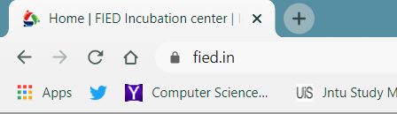

• **The Apply for RKVY** -> Sahas Page/ Saksham Page image had vague borders, a bit of twitching around the cropping of the image proved to bring about visual changes in the overall outlook.

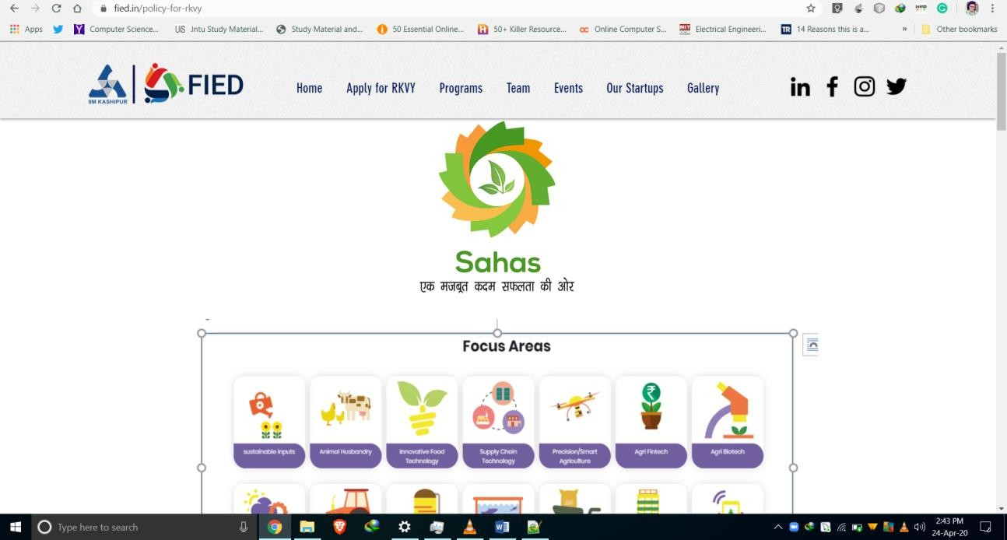

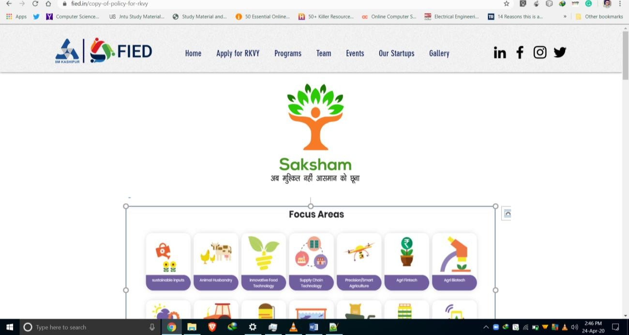

• **Eliminated** the previous Focus Areas Image for better Site Appeal.

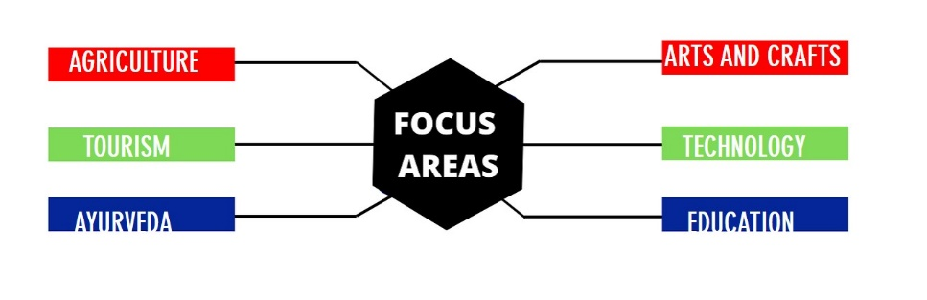

* And Replaced it with the Following Design **(courtesy Deepak)**

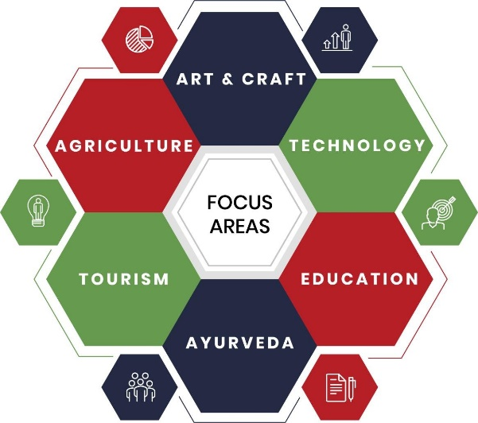

* Worked upon a new color palette for the Website, **Blue White Theme**

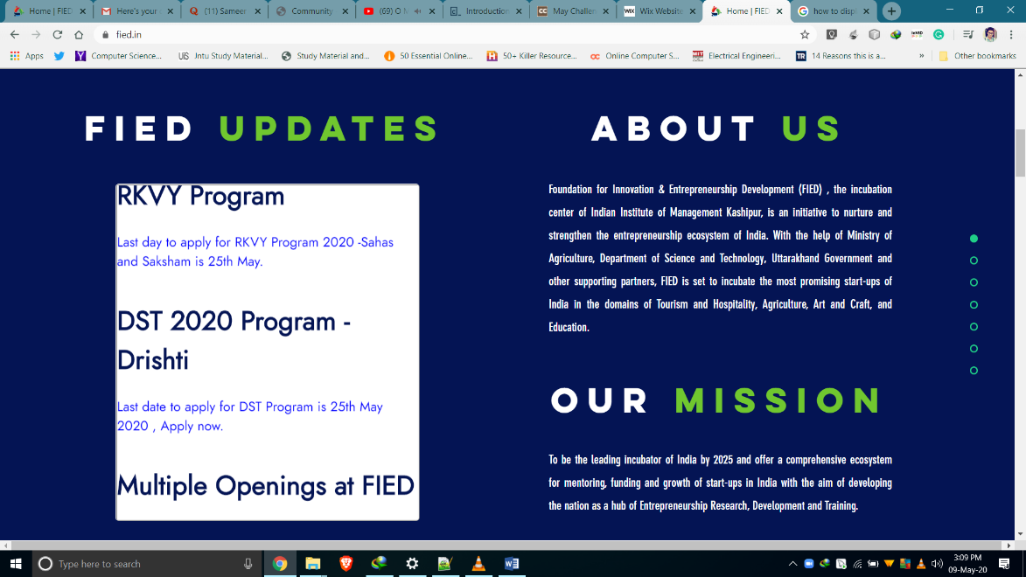

• **Cut Costs by 100% and improved efficiency** by implementing the Dynamic Counter by simply making Custom Raw code instead of PAID outsourced Counter Plugin. (10$/month = Rs. 8400/year)

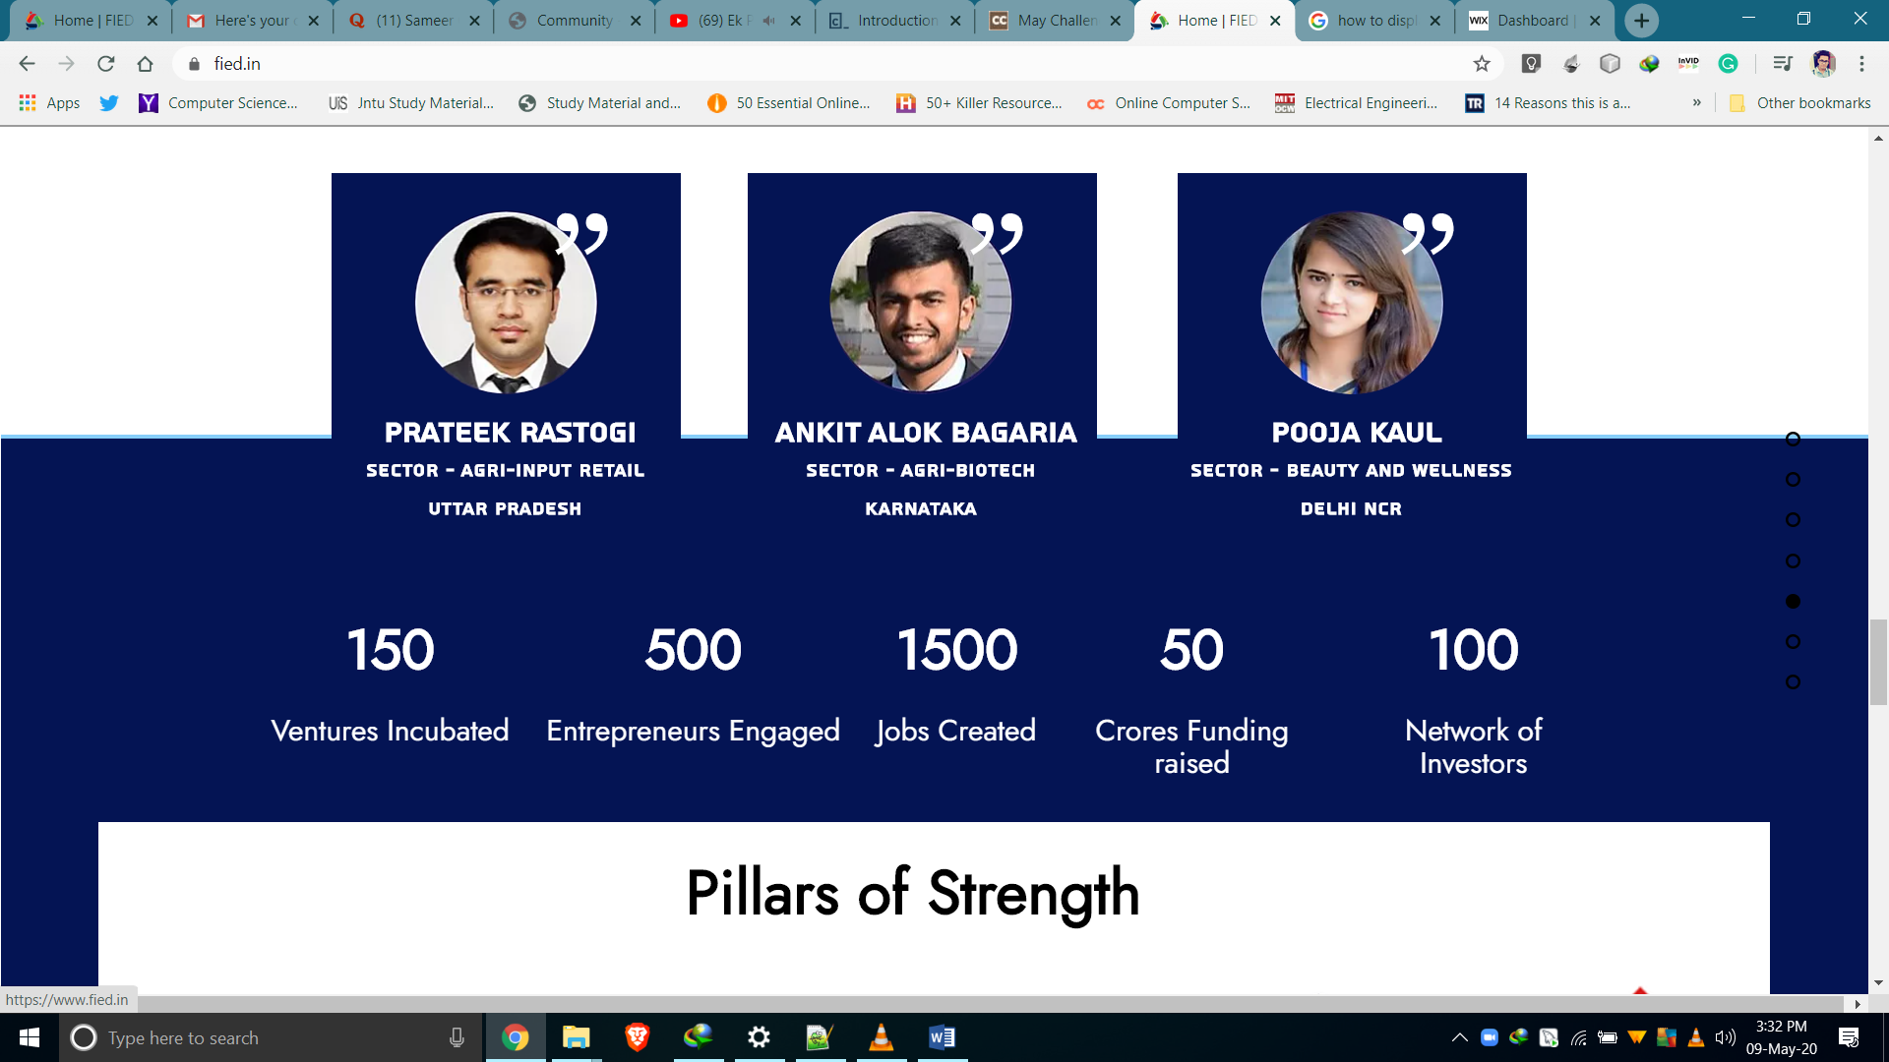

• **Cut Costs by 100% and improved design** by implementing the News Ticker by simply making Custom Raw code instead of PAID outsourced Counter Plugin. (Rs. 1800/Year)

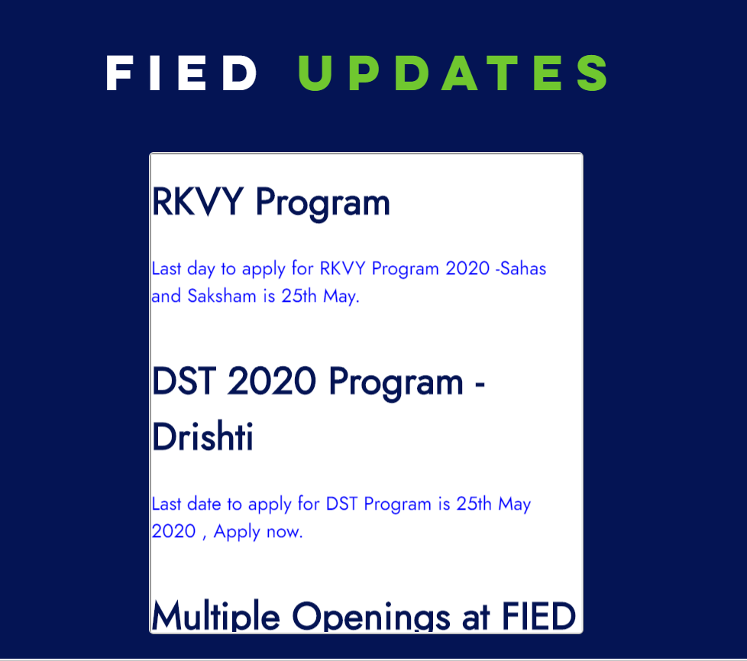

• **Improvised design** of the FOCUS AREASby implementing Animation in for short Description about each focus area.

Description Content Curtesy **( Ayush )**

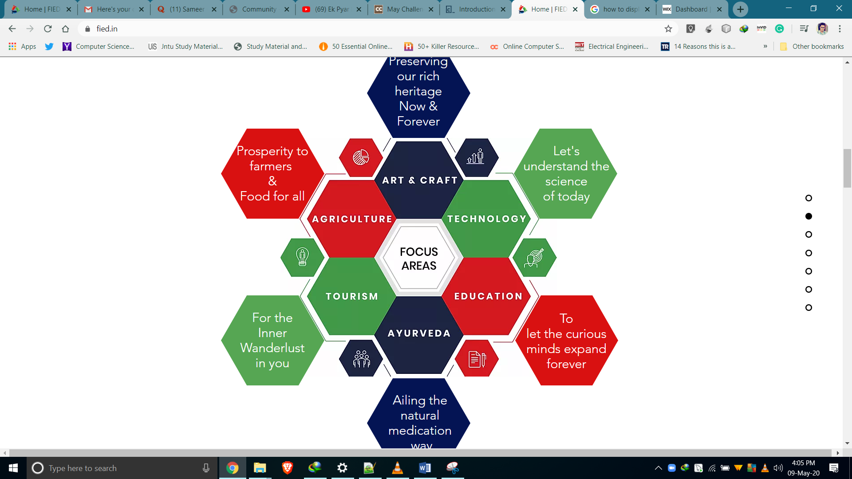

• **Added the Hover** functionality to the Testimonials which previously was an Image, now changed into respective Cards.

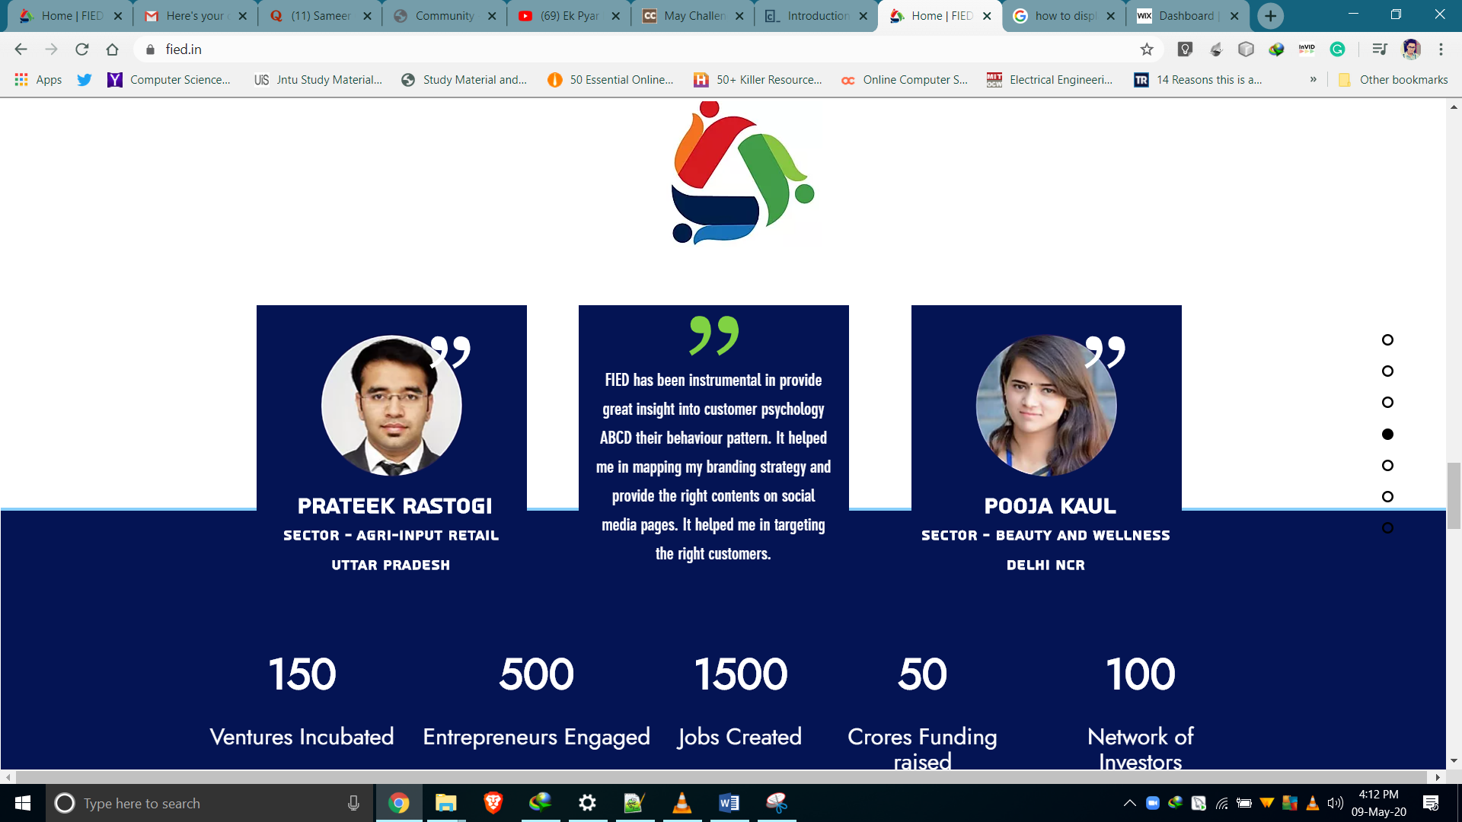

• **Improved and Implemented the New Design and Color Palette** of the SAHAS and SAKSHAM Pages and also **created** the **DRISHTI** page with the same new design in mind.

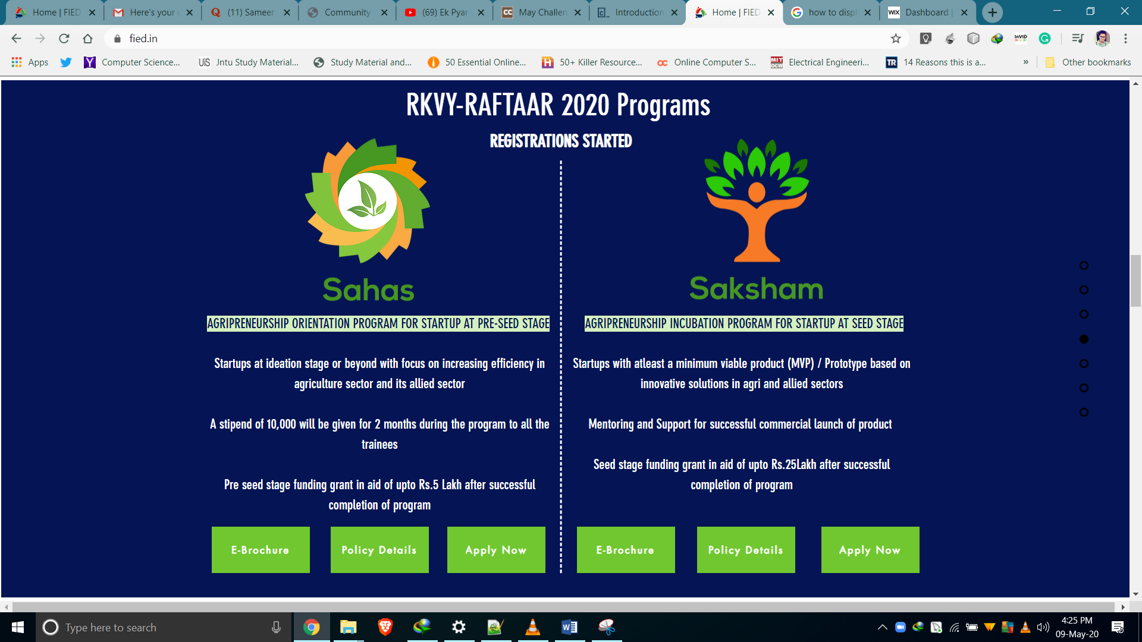

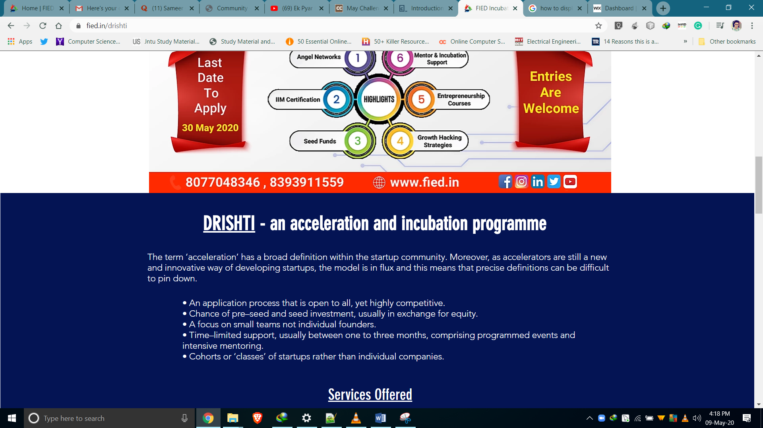

• **Added New Images to the Advisory Committee and Student Members** of the FIED Team Page.

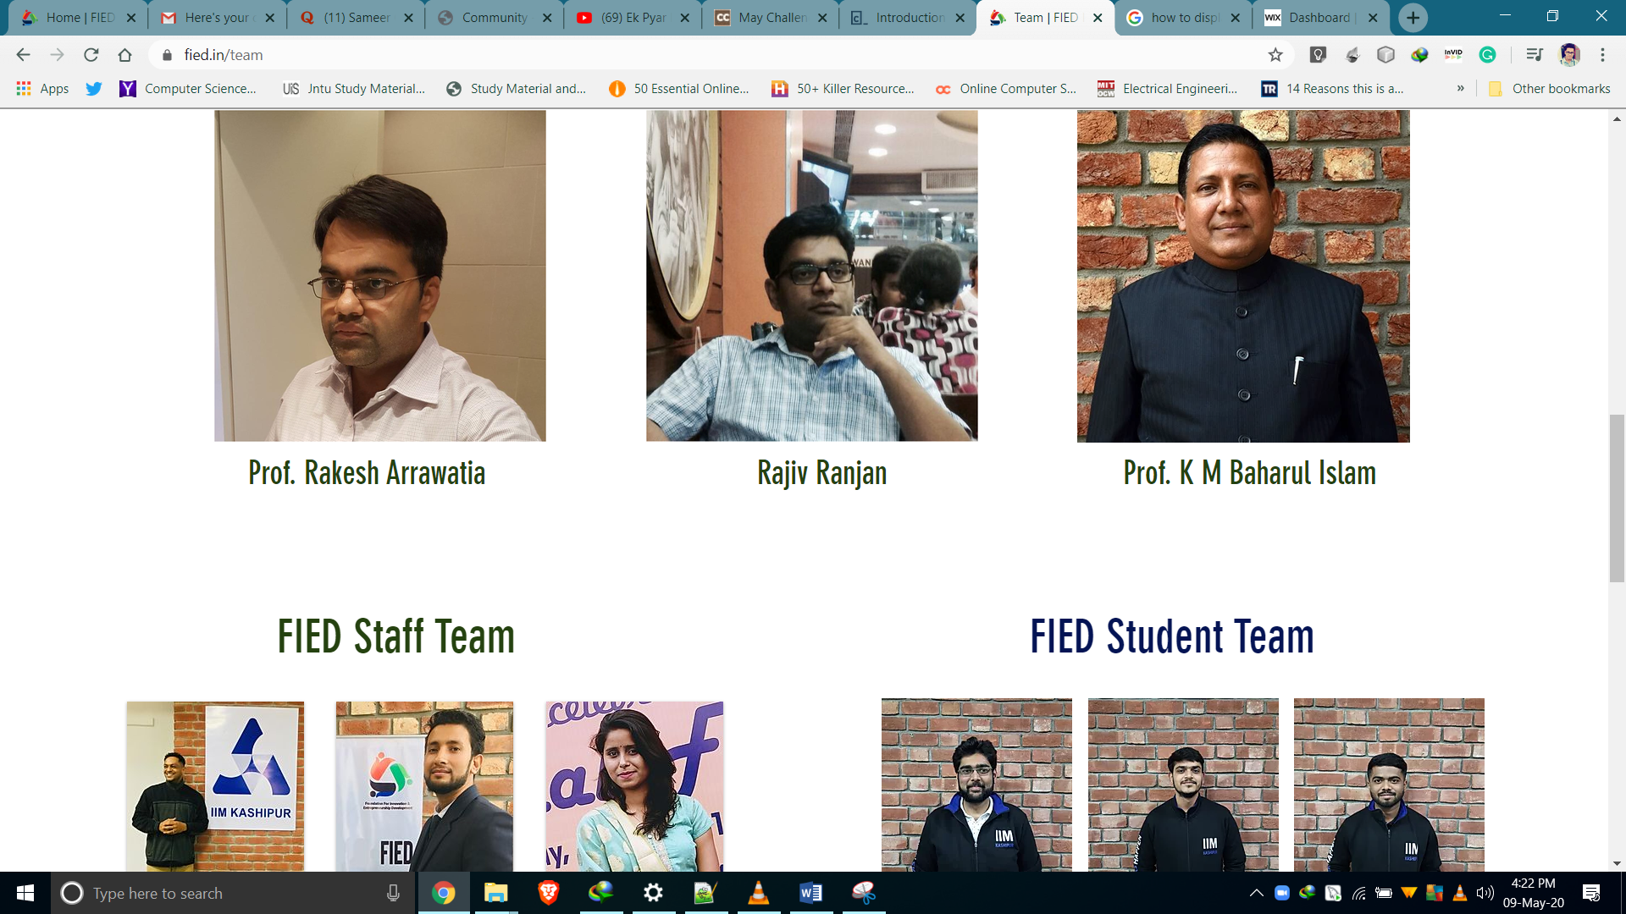

**Suggestions for Change in the Design after the Review of the Authorities.**

